HPSD Board of Trustees Meeting
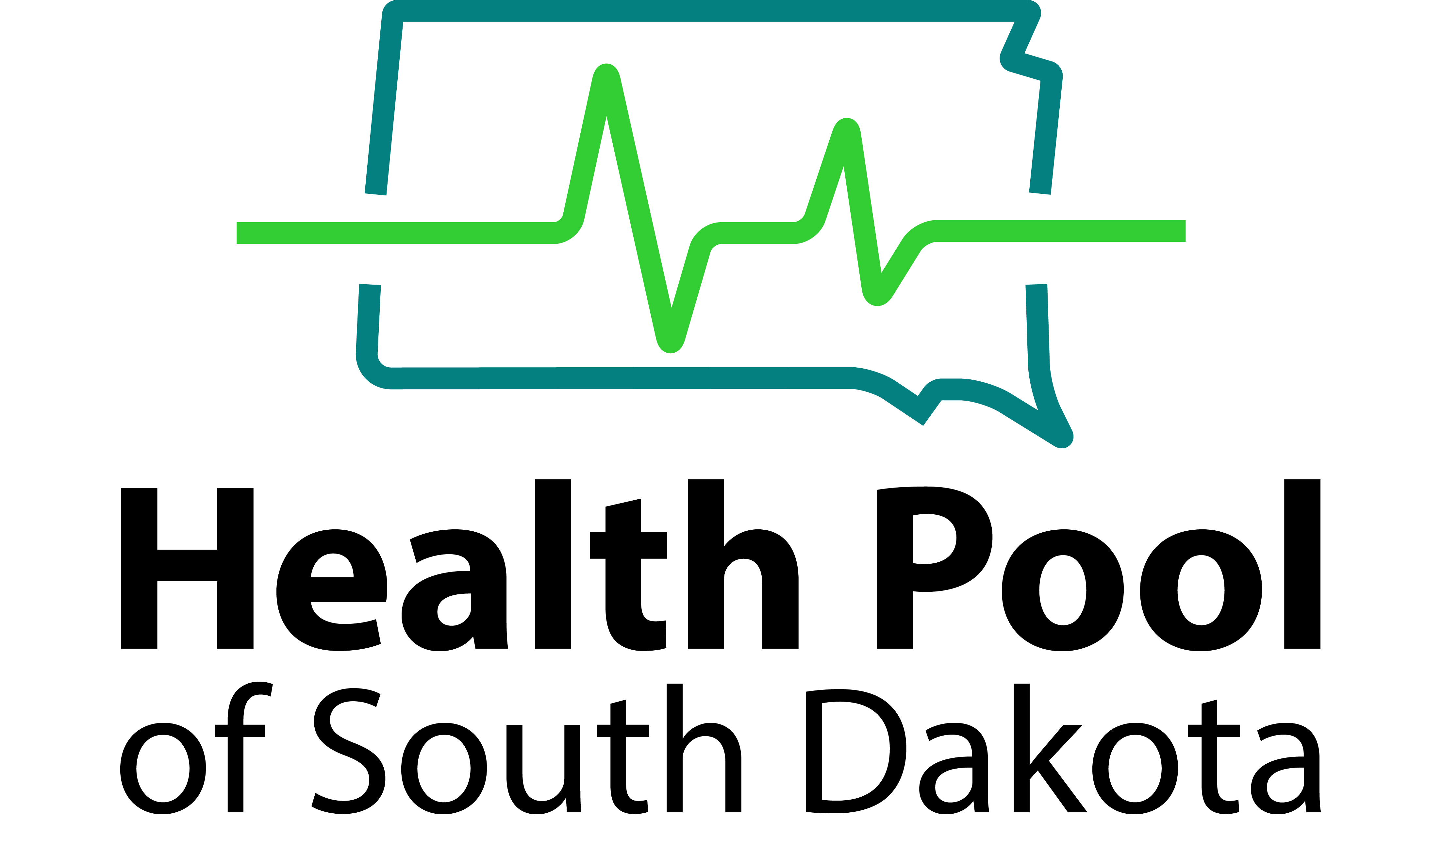

Health Pool of South Dakota
Friday, December 5, 2025, 8:00 AM CST
Clubhouse Hotel, 2320 S. Louise Ave., Sioux Falls SD 57106

Agenda
- Welcome and Approve Agenda
- Approval of Board Meeting Minutes for September 16, 2025 and September 25, 2025 Board Meetings
- 2025 Q3 Compiled Financials - Ryan Donahue and Grant Maciej, Eide Bailly
- New Business
Authorized control level (ACL) minimum. Maximum allowable amount of reserve utilization
- Investment Report - Lauren Gilbertson and Erik Ustad, First National Bank in Sioux Falls
- Wellmark Quarterly Review - Carlotta Carr, Wellmark
- Management Report - Lisa Nold, SDML
- New Business
  - Approve 2026 Endorsement and Administrative Services Agreements
  - Review 2026 Meeting Dates
- Adjourn

